**Assisted Practice: 2.4 IIFEs and Functions**

This section will guide you to:

* Create a JavaScript project in your IDE
* Write a program in JavaScript to create IIFEs and functions

This lab has three subsections, namely:

2.4.1 Writing a program in JavaScript to verify implementations of IIFEs and functions

2.4.2 Executing the program and verifying working of IIFEs and functions

2.4.3 Pushing the code to your GitHub repositories

**Step 2.4.1:** Writing a program in JavaScript to verify implementations of IIFEs and functions

* Open Visual Studio Code
* *[Right click]* on the **src** folder of the project
* Select *New File* -> Enter the filename as **index.html**
* Write the code shown below resolving the warning and errors due compatibility-related issues

<html>

<body>

<h1>MEAN Stack</h1>

<p> Lesson 3 Demos </p>

<script src="IIFEs_Functions.js"></script>

</body>

</html>

* *[Right click]* on the **src** folder of the project
* Select *New File* -> Enter the filename as **IIFEs_Functions.js**
* Execute the code shown below resolving the warning and errors due compatibility-related issues

//Function as an argument

console.log("\n Functions as an argument demo");

var add = (a, b) => {

return a+b;

}

var subtract = (a, b) => {

return a-b;

}

var data = (func) => {

// get data from user or other external source

var num1 = 10;

var num2 = 20;

return func(num1, num2);

}

console.log(data(add));

console.log(data(subtract));

//Funtions returning Functions

console.log("\n Functions returning Function demo");

const multi = (integer) => (anotherInteger) => integer * anotherInteger;

const div = (integer) => (anotherInteger) => integer / anotherInteger;

const result1 = multi(10)(50);

const result2 = div(25)(5);

console.log(result1);

console.log(result2);

**Step 2.4.2:** Executing the program and verifying working of IIFEs and functions

Before you execute the program, check for syntactical corrections. If no errors are found, follow the steps mentioned below:

* Go to Extensions and download **Live Server**
* *[Right click]* on the **index.html** file of the project
* Select *Open with Live Server*
* Right click when the server starts running. Select *Inspect*.Click on **Console**

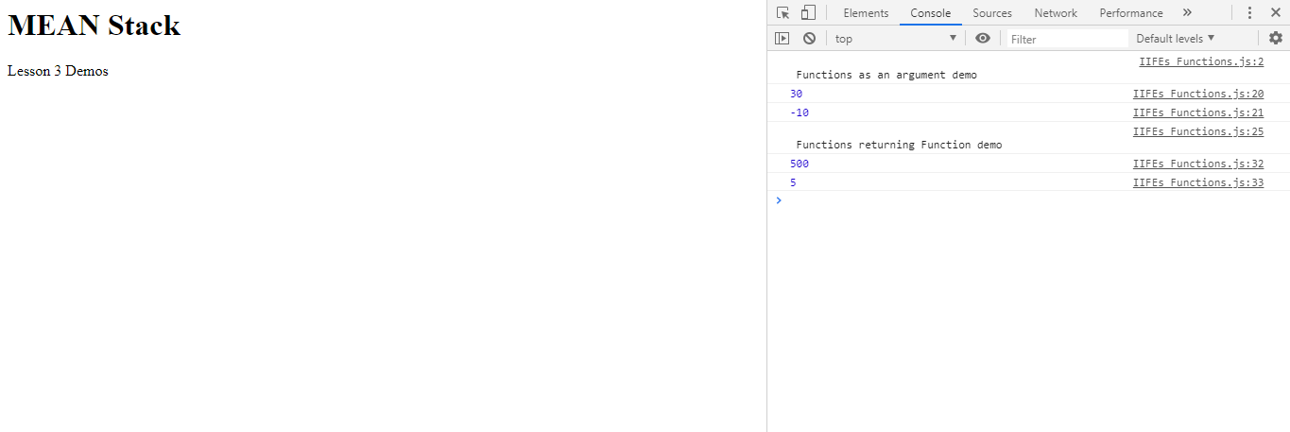

**Step 2.4.3:** Pushing the code to your GitHub repositories

* Open your command prompt and navigate to the folder where you have created your files.

**cd <folder path>**

* Initialize your repository using the following command:

**git init**

* Add all the files to your git repository using the following command:

**git add .**

* Commit the changes using the following command:

**git commit . -m “Changes have been committed.”**

* Push the files to the folder you initially created using the following command:

**git push -u origin master**